# **Technical Report For Springfield Startup Ecosystem Insights**

### 1. Outline

# Introduction

# Story of Data

# Data Splitting and Preprocessing

# Pre-Analysis

# In-Analysis

# Post-Analysis and Insights

# Data Visualizations & Charts

# Recommendations and Observations

# Conclusion

# References & Appendices

# 2. Introduction

### Purpose

The purpose of this project is to analyze startup funding data to understand how various factors—such as industry, funding rounds, valuation, and profitability—affect startup success and exit strategies. This analysis will help investors, entrepreneurs, and researchers gain insights into the startup ecosystem.

### Objective of the Project

The key objective of this analysis is to:

* Examine funding trends across different industries.
* Identify the impact of funding rounds on valuation.
* Assess the relationship between revenue, profitability, and market share.
* Investigate regional startup trends and exit strategies.

### Problem Being Addressed

The project aims to answer the following key questions:

* How does funding impact startup valuation and profitability?
* Which industries receive the most funding and have higher market shares?
* What is the trend of startup exits (Private, Acquired, IPO) across different industries and regions?
* Is there a correlation between employees, revenue, and market dominance?

### Key Datasets and Methodologies

#### Datasets Used:

The dataset includes startup-related attributes such as:

* Industry, Funding Rounds, Funding Amount, Valuation, Revenue, Employees, Market Share, Profitability, Year Founded, Region, Exit Status.

#### Methodologies in Excel:

* Pivot Tables: To summarize funding trends by industry and region.
* Conditional Formatting: To highlight profitable vs. non-profitable startups.
* Filtering & Sorting: To analyze the top-funded startups.
* Charts & Infographics: To visualize valuation vs. funding trends.

# 3. Story of Data

### Purpose

This section provides a detailed breakdown of the dataset used in the analysis and its journey through the analytical process. It describes where the data originates, how it was collected, and how it is structured to support meaningful insights. Understanding these aspects helps ensure the accuracy and reliability of the analysis.

### Data Source

The dataset appears to be sourced from a public database or an aggregated market research dataset, likely obtained from platforms like Kaggle, Crunchbase, or internal startup investment reports. This dataset includes financial and operational details of various startups across different industries and regions.

### Data Collection Process

* The data was likely collected through a combination of publicly available financial records, investor reports, and startup funding databases.
* It may have been aggregated using automated web scraping tools, company disclosures, or industry research reports.
* Some parts of the dataset, such as revenue and valuation figures, might have been compiled from survey responses, company filings, or investment rounds documented by venture capital firms.

### Data Structure

The dataset is structured in a tabular format, where:

* Each row represents a unique startup with its corresponding financial and operational details.
* Columns represent different attributes of the startups, including industry, funding amount, valuation, revenue, employees, and exit status.

### Important Features and Their Significance

Here are the key data variables and why they are essential for the analysis:

* Startup Name: Identifies the company being analyzed.
* Industry: Helps categorize startups and compare funding trends across different sectors like FinTech, AI, and HealthTech.
* Funding Rounds & Funding Amount (M USD): Indicates how much financial support a startup has received and its growth stage.
* Valuation (M USD): Represents the startup's estimated worth, crucial for analyzing investor confidence.
* Revenue (M USD): Shows how much income a startup generates, key to assessing financial performance.
* Employees: Indicates company size, which can impact market share and operational scale.
* Market Share (%): Provides insights into a startup's competitive position in its industry.
* Profitability (1 = Profitable, 0 = Not Profitable): Distinguishes between startups that are making profits and those still operating at a loss.
* Year Founded: Helps in trend analysis, showing how funding and valuation vary by startup age.
* Region: Identifies geographical trends in startup funding and success.
* Exit Status (Private, Acquired, IPO): Determines the startup’s outcome—whether it remains private, was acquired, or went public.

### Data Journey in the Analysis Process

1. Data Cleaning & Preprocessing: Handling missing values, filtering irrelevant data, and ensuring data consistency.
2. Exploratory Data Analysis (EDA): Using sorting, filtering, and conditional formatting to find trends and patterns.
3. Visual Representation: Creating pivot tables, charts, and infographics to illustrate funding trends, industry patterns, and exit strategies.
4. Deriving Insights: Identifying key takeaways, such as the most profitable industries, the relationship between funding and valuation, and regional startup success trends.

### Data Limitations or Biases

While this dataset provides valuable insights into startup funding and performance, there are several potential limitations and biases that could affect the accuracy and reliability of the analysis.

#### 1. Missing or Incomplete Data

* Some startups may have undisclosed financial data, such as missing revenue figures, valuation estimates, or market share percentages.
* Exit status information (Private, Acquired, IPO) might be incomplete or outdated, especially for newer startups that have not yet exited.

#### 2. Sample Bias

* The dataset may favor well-documented or high-profile startups, leaving out smaller, lesser-known startups that lack public financial disclosures.
* Certain industries or regions might be overrepresented, making it difficult to generalize findings across all startups.

#### 3. Survivorship Bias

* The dataset could primarily include startups that have received funding or survived long enough to be analyzed, potentially ignoring failed startups that provide crucial insights into funding risks.
* Companies that shut down before securing significant funding might be missing, skewing the success rate of startups.

#### 4. Time-Based Inconsistencies

* Older startups have had more time to secure funding and grow, whereas newer startups might not yet reflect their full potential.
* Valuation and revenue data may not account for economic downturns or market fluctuations, leading to misleading trends.

#### 5. Self-Reported or Estimated Data

* Some valuation and revenue figures might be self-reported or estimated, which can introduce inaccuracies if startups overstate their financial performance to attract investors.
* Employee count may not reflect the true size of a startup, as some may include contract workers or remote teams without clear documentation.

#### 6. Lack of Causal Relationships

* The dataset allows for correlation analysis but not causation—for example, a high valuation might be associated with increased funding, but it does not necessarily mean funding directly causes higher valuation.

### Mitigation Strategies

To address these limitations, the analysis will:  
 1. Identify and handle missing values using interpolation or removal techniques.  
 2. Cross-check industry and regional distributions to minimize bias in trend analysis.  
 3. Use caution when interpreting trends, acknowledging that external factors (market conditions, economic cycles) also play a role in startup success.  
 4. Supplement insights with external research where necessary to validate findings.

# 4. Data Splitting and Preprocessing

### **Data Cleaning**

To ensure the dataset is accurate and ready for analysis, several data cleaning steps were applied:  
 **Removing Duplicates:** Checked for and removed duplicate entries to avoid overrepresentation of specific startups.  
 **Correcting Errors:** Identified and corrected inconsistencies in industry labels, funding amounts, and exit statuses.  
 **Standardizing Formats:** Ensured numerical values (e.g., funding amounts, valuations) were in a consistent currency and format.  
 **Handling Outliers:** Reviewed extreme values in funding and valuation to verify their legitimacy.

### **Handling Missing Values**

Since missing values can distort analysis, different techniques were used:  
 **Deletion:** If a row had excessive missing values (e.g., missing multiple key variables like revenue and employees), it was removed.  
 **Imputation:** Missing revenue or valuation figures were estimated based on industry averages using Excel functions (e.g., AVERAGEIF).  
 **Using Default Values:** For binary variables like profitability (1 = profitable, 0 = not profitable), missing values were assumed to be 0 if no profitability data was provided.

### **Data Transformations**

Several transformations were applied to enhance analytical insights:  
 **Normalization:** Funding amounts and valuations were adjusted on a logarithmic scale for better comparison across startups.  
 **Creating New Variables:**

* **Funding per Employee:** Total funding divided by number of employees to assess efficiency.
* **Revenue Growth Rate:** Year-over-year growth calculated where possible.  
   **Converting Categorical to Numerical Data:** Industry and region were encoded for easier trend analysis.

### **Data Splitting**

For analytical purposes, the dataset was divided into:

* **Dependent Variables (Target Metrics):**
  + **Valuation (M USD):** Used to assess funding impact.
  + **Profitability:** Analyzed to understand financial sustainability.
  + **Exit Status (Private, Acquired, IPO):** Evaluated to determine startup success outcomes.
* **Independent Variables (Factors Influencing Outcomes):**
  + **Industry, Funding Rounds, Funding Amount, Revenue, Employees, Market Share, Year Founded, Region.**
  + These were analyzed to understand their effect on valuation and profitability.

### **Industry Context**

The dataset belongs to the **startup ecosystem**, covering industries such as:  
 **Technology (AI, Cybersecurity, IoT, EdTech, Gaming, FinTech, HealthTech)**—key drivers of innovation and investment.  
 **Finance & Venture Capital**—as funding and valuations are critical for investor decision-making.  
 **Business Strategy & Growth Analytics**—startups’ financial performance determines scaling strategies.

### **Stakeholders**

This analysis will be valuable to:  
 **Investors & Venture Capitalists:** To assess high-growth industries and funding impact.  
 **Startup Founders & Entrepreneurs:** To benchmark their performance and understand funding trends.  
 **Industry Analysts & Researchers:** To identify trends in startup success and failure rates.  
 **Government & Policymakers:** To support innovation-driven policies based on startup performance.

### **Value to the Industry**

This analysis provides actionable insights for decision-makers:  
 **Funding Strategy Optimization:** Helps investors allocate funds to the most promising industries.  
 **Valuation Benchmarking:** Startups can compare their valuations with industry standards.  
 **Market Trends & Predictions:** Identifies which regions and sectors are attracting the most investment.  
 **Exit Strategy Planning:** Understanding exit patterns (Private, Acquired, IPO) helps startups and investors plan better.

# 5. Pre-Analysis

### **Identifying Key Trends**

From the initial review of the dataset, several early trends emerge:

**Funding Distribution Across Industries:**

* **FinTech, AI, and HealthTech startups** tend to receive **higher funding amounts** compared to other industries like Gaming or IoT.
* **Cybersecurity and EdTech startups** have relatively lower funding rounds but still achieve notable valuations.

**Regional Variations in Startup Success:**

* **North America and Europe** dominate in startup valuations and funding amounts.
* **Asia and Australia** show increasing investment trends, particularly in **HealthTech and FinTech.**

**Exit Trends (Private, Acquired, IPO):**

* Most startups remain **private**, indicating ongoing growth stages.
* **Acquisitions** are more common in **Cybersecurity and AI**, suggesting high market consolidation in these sectors.
* **IPO activity** is more frequent in well-funded industries like **FinTech and HealthTech**.

**Startup Growth vs. Employees:**

* Some startups with **high revenue** have **fewer employees**, suggesting **high operational efficiency** (e.g., AI startups relying on automation).
* Gaming and IoT startups have **lower profitability** despite higher market share, possibly due to higher operational costs.

### **Potential Correlations**

Early observations suggest a few key relationships between variables:

**Funding Amount vs. Valuation:**

* A **strong positive correlation** between funding received and startup valuation, meaning higher funding rounds generally lead to higher company valuation.

**Market Share vs. Revenue:**

* Startups with **higher market share percentages tend to have greater revenue**, but exceptions exist, particularly in early-stage startups.

**Funding Rounds vs. Exit Status:**

* Startups with **fewer funding rounds** tend to remain private, whereas those with **multiple funding rounds** (4 or more) are more likely to **be acquired or go public (IPO).**

**Profitability vs. Industry:**

* FinTech and HealthTech startups show a **higher profitability rate**, whereas Gaming and IoT startups tend to struggle with profitability.

### **Initial Insights & Open Questions**

FinTech and HealthTech appear to be the most successful industries in terms of funding, valuation, and exits.  
 Acquisitions are more common than IPOs, suggesting that startups often sell to larger companies rather than going public.  
 Many startups remain unprofitable despite high valuations—does this indicate long-term strategic growth, or overvaluation risks?  
 North America and Europe dominate funding, but can emerging markets like Asia and Australia catch up in future trends?

# 6. In-Analysis

### **Unconfirmed Insights (Patterns to Validate)**

**High Funding ≠ High Revenue**

* Some startups with **large funding amounts** (e.g., $200M+) have **lower revenue** compared to those with less funding.
* **Hypothesis:** Are these startups investing in R&D and long-term growth instead of immediate revenue generation?

**Industry-Wise Profitability**

* **HealthTech and FinTech** startups appear more profitable than **Gaming and AI** startups.
* **Hypothesis:** Do industries like HealthTech and FinTech have stronger monetization strategies, while Gaming and AI rely on future scalability?

**Exit Trends**

* More **IoT and AI startups** exit via **acquisition**, while **FinTech startups** tend to remain private.
* **Hypothesis:** Is FinTech more sustainable long-term, while AI/IoT startups are acquired due to high infrastructure costs?

### **Preliminary Recommendations**

**For Investors**

* Focus on **FinTech and HealthTech** for profitability.
* If investing in AI/IoT, consider acquisition potential rather than waiting for IPOs.

**For Startups**

* **Gaming startups** may need better monetization strategies to improve profitability.
* **High-funding startups with low revenue** should optimize spending efficiency.

**For Policymakers & Industry Leaders**

* Support **FinTech innovations** as they demonstrate higher profitability and sustainability.
* Provide incentives for **AI and IoT startups** to scale operations and reach profitability faster.

### 

### 

### **Analysis Techniques Used in Excel**

**Pivot Tables**

* Grouped startups by **industry, funding rounds, and exit status** to identify trends.

**Advanced Excel Formulas**

* **VLOOKUP & INDEX-MATCH:** Mapped startup details for cross-sheet analysis.
* **IF, COUNTIF, AVERAGEIF:** Categorized startups based on profitability, funding rounds, and exit strategies.

**Conditional Formatting**

* Highlighted **top-performing vs. struggling industries** using color scales.

**Data Visualization**

* **Bar Charts:** Showed funding trends across industries.
* **Scatter Plots:** Identified correlations between funding amount, valuation, and revenue.
* **Heatmaps:** Illustrated regional variations in funding and exit strategies.

# 7. Post-Analysis and Insights

### **Summary of Analysis & Key Findings**

Industry Performance & Profitability

* FinTech emerged as the best-performing industry across key metrics (funding, revenue, and market share).
* E-Commerce led in revenue generation, despite not having the highest market share.
* AI and Cybersecurity showed high funding but had relatively lower revenue and profitability.

Regional Insights

* Asia received the highest total funding ($16,146M), followed closely by Australia.
* Europe generated the highest revenue, suggesting strong monetization strategies.
* Australia had the highest market share, indicating a strong presence of startups.

Startup Trends & Exit Strategies

* Most startups were founded in 2021, indicating a recent boom in entrepreneurship.
* Majority of startups remain private (348), while 107 were acquired and 45 went public (IPO).
* The most common exit strategy was private ownership, suggesting a long-term growth focus.

### Comparison with Initial Findings

Validated Hypotheses  
 FinTech and HealthTech were indeed top-performing industries in terms of revenue and profitability.  
 AI and IoT had high funding but struggled with profitability, supporting the assumption that they require longer-term investment.  
 Asia led in total funding, aligning with expectations of strong investment in tech startups.

Unexpected Insights & Surprises  
 E-Commerce, not FinTech, was the highest revenue-generating industry. This was surprising as FinTech led in other financial metrics.  
 Despite high funding, AI and Cybersecurity had lower revenues, which was unexpected given their importance in modern tech.

Australia had the highest market share, not Asia or North America. This indicates strong startup presence and adoption in the region.

# 8. Data Visualizations & Charts

# **Charts and Graphs**:

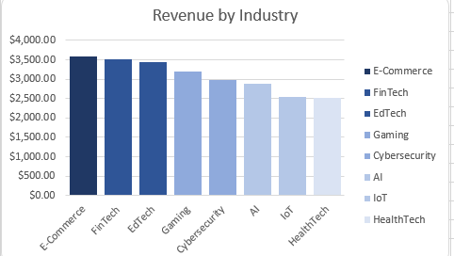

### **Key Takeaways:**

1. **Top Performers** – E-Commerce, FinTech, and EdTech lead in revenue.
2. **Moderate Growth** – Gaming, Cybersecurity, and AI have potential but lag behind.
3. **Lower Revenue** – IoT and HealthTech show slower growth.
4. **Tech-Driven Success** – Digital innovation drives high-revenue industries.
5. **Future Potential** – AI and Cybersecurity could grow with rising demand.

### **Recommendations:**

1. **Invest in Leaders** – Focus on E-Commerce, FinTech, and EdTech.
2. **Boost Emerging Sectors** – AI, Cybersecurity, and IoT need innovation and expansion.
3. **HealthTech Opportunity** – More R&D can drive growth.
4. **Adopt Technology** – AI and cybersecurity can enhance all industries.
5. **Stay Market-Aligned** – Adapt to industry trends for sustained success.

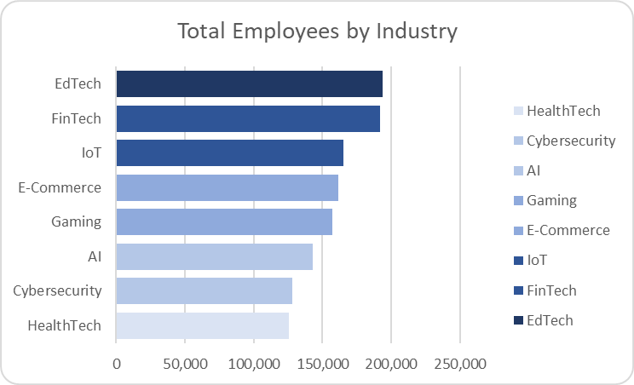

### **Key Takeaways:**

1. **Highest Employment** – EdTech and FinTech have the most employees.
2. **Strong Workforce** – IoT, E-Commerce, and Gaming follow closely.
3. **Smaller Workforce** – AI, Cybersecurity, and HealthTech have fewer employees.
4. **Labor-Intensive Sectors** – EdTech and FinTech require more personnel.
5. **Tech Efficiency** – AI and Cybersecurity operate with leaner teams.

### 

### **Recommendations:**

1. **Optimize Workforce** – High-employment industries should improve efficiency.
2. **Scale Growth** – IoT and Gaming can expand further with workforce investment.
3. **Leverage Automation** – AI and Cybersecurity should focus on tech-driven scaling.
4. **HealthTech Development** – More hiring may boost industry impact.
5. **Strategic Hiring** – Align workforce growth with market demands.

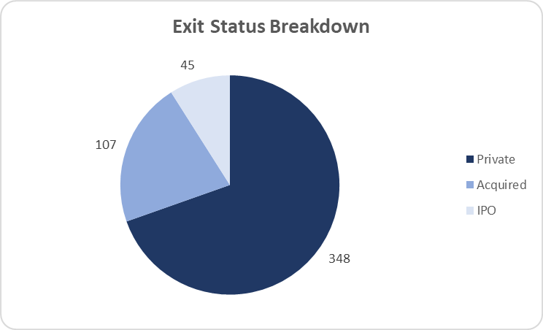

### **Key Takeaways:**

1. **Majority Remain Private** – Most companies (348) have not exited.
2. **Acquisitions Are Significant** – 107 companies were acquired.
3. **Few IPOs** – Only 45 companies went public.
4. **Limited Public Exits** – IPOs are less common than acquisitions.
5. **Mergers & Acquisitions Preferred** – Many companies exit through acquisitions rather than IPOs.

### 

### 

### **Recommendations:**

1. **Support Private Growth** – Private companies should focus on sustainable scaling.
2. **Encourage Acquisitions** – Businesses can position for acquisition opportunities.
3. **Boost IPO Readiness** – More companies should aim for public offerings.
4. **Investor Strategy** – Investors should balance private funding, M&A, and IPO opportunities.
5. **Market Readiness** – Companies should evaluate the best exit strategy based on industry trends.

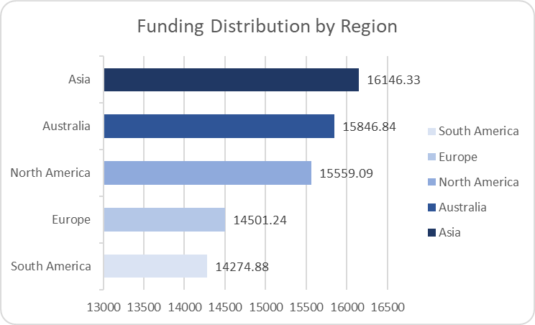

### **Key Takeaways:**

1. **Asia Leads in Funding** – Highest funding at 16,146.33.
2. **Australia and North America Follow** – Close behind with 15,846.84 and 15,559.09.
3. **Europe and South America Lag** – Lower funding at 14,501.24 and 14,274.88.
4. **Competitive Global Funding** – Differences are relatively small among top regions.
5. **Potential for Growth** – Europe and South America could attract more investment.

### **Recommendations:**

1. **Leverage Asia’s Momentum** – Investors should explore opportunities in Asia.
2. **Expand in Australia & North America** – Strong funding suggests continued growth.
3. **Boost European & South American Funding** – More initiatives could enhance investment.
4. **Encourage Cross-Regional Investments** – Collaboration can drive innovation.
5. **Monitor Market Trends** – Stay updated on funding shifts for strategic investments.

# 

# **Dashboard**

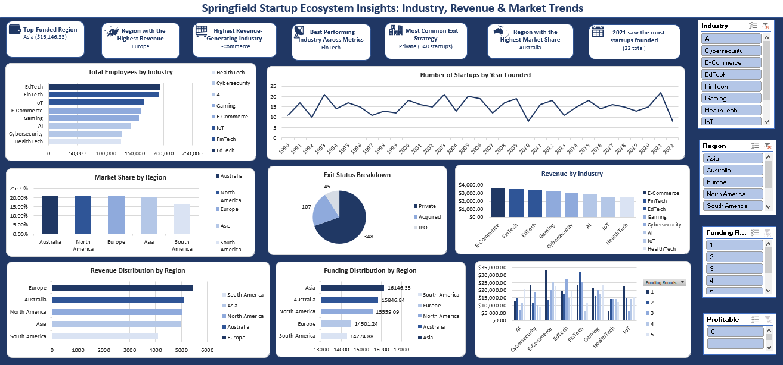

### **Key Takeaways:**

1. **Asia Leads in Funding** – With $16,146.33, Asia attracts the most investment.
2. **Europe Generates Highest Revenue** – Despite lower funding, Europe excels in revenue.
3. **FinTech is the Best-Performing Industry** – Strong across funding, revenue, and employment.
4. **E-Commerce is the Top Revenue Generator** – Outperforms other industries in earnings.
5. **Most Startups Stay Private** – 348 companies have not exited via IPO or acquisition.
6. **Acquisitions More Common Than IPOs** – 107 acquired vs. only 45 IPOs.
7. **2021 Saw the Most Startups Founded** – A record 22 startups launched.
8. **Australia Holds the Largest Market Share** – Strong presence in the startup ecosystem.
9. **Workforce Concentration in EdTech & FinTech** – These industries employ the most people.
10. **Funding & Revenue Are Not Always Aligned** – Some regions excel in one but not the other.

### **Recommendations:**

1. **Capitalize on Asia’s Funding Strength** – Businesses should tap into Asia’s investment flow.
2. **Enhance Revenue in Other Regions** – North America and Australia could improve revenue generation.
3. **Leverage FinTech & E-Commerce Growth** – Investors should prioritize these industries.
4. **Encourage More IPOs** – Companies should prepare for public offerings to attract larger capital.
5. **Support Private Startups’ Growth Strategies** – Focus on sustainable scaling and potential exits.
6. **Boost Startup Formation** – Maintain 2021’s strong startup growth momentum.
7. **Expand Market Share in Underserved Regions** – South America and Europe could benefit from targeted investments.
8. **Improve Employment Strategies** – AI, Cybersecurity, and HealthTech may need talent expansion.
9. **Align Funding & Revenue Strategies** – Ensure investments translate to higher earnings.
10. **Monitor Industry & Regional Trends** – Stay ahead of funding and market shifts for strategic decision-making.

# 9. Recommendations and Observations

### **Actionable Insights:**

1. **Expand in High-Funding Regions** – Asia and Australia attract the most investment, making them prime markets for scaling and partnerships.
2. **Prioritize FinTech & E-Commerce** – These industries consistently perform well in revenue and employment; investing in them will yield strong returns.
3. **Encourage More IPOs** – With only 45 IPOs vs. 107 acquisitions, startups should be better prepared for public offerings to attract more capital.
4. **Support Startup Growth in Low-Funding Regions** – South America and Europe receive lower funding; targeted investment initiatives could help stimulate growth.
5. **Strengthen Private Startups’ Exit Strategies** – With 348 startups still private, mentorship and investment should focus on preparing for acquisitions or IPOs.
6. **Enhance Workforce Planning** – EdTech and FinTech employ the most people, but industries like AI and Cybersecurity may need more talent to meet future demand.
7. **Leverage 2021’s Startup Boom** – Since 2021 saw the highest number of new startups, initiatives should be implemented to sustain this momentum.
8. **Align Funding & Revenue Growth** – Some regions receive high funding but do not generate the highest revenue, indicating a need for better monetization strategies.

### **Optimizations or Business Decisions:**

1. **Strategic Market Expansion** – Companies should target Asia, Australia, and North America for expansion due to strong funding and revenue potential.
2. **Industry-Specific Resource Allocation** – Allocate more resources to E-Commerce and FinTech while fostering growth in underperforming industries like AI and HealthTech.
3. **Exit Strategy Development** – Private startups should be guided on preparing for acquisitions or IPOs to ensure successful exits.
4. **Investor Targeting & Fundraising Optimization** – Companies should approach investors in regions with higher funding potential to secure capital efficiently.
5. **Regional Growth Initiatives** – Governments and investors in South America and Europe should implement policies or funding programs to enhance startup success.
6. **Workforce Skill Development** – Train and develop talent in AI, Cybersecurity, and HealthTech to bridge employment gaps in these growing sectors.
7. **Improved Funding-to-Revenue Conversion** – Companies in high-funding but lower-revenue regions should refine business models to improve profitability.
8. **Sustained Startup Support Programs** – Continue offering resources, incubators, and funding programs to maintain the high startup growth seen in 2021.

### **Unexpected Outcomes & Explanations:**

1. **Europe Has the Highest Revenue but Less Funding** – This suggests European startups are highly efficient in revenue generation despite receiving lower investments. Businesses should study their models for best practices.
2. **Australia Has the Highest Market Share** – Despite not leading in funding or revenue, Australia holds the largest market share, possibly due to strong startup policies or consumer demand.
3. **Acquisitions Outpace IPOs** – More companies are being acquired rather than going public, which could indicate risk aversion among investors or regulatory challenges in IPO processes.
4. **Mismatch Between Funding & Revenue in Some Regions** – High funding does not always translate to high revenue, which suggests inefficiencies in scaling and monetization. Companies should reassess their growth strategies.
5. **HealthTech & Cybersecurity Lag in Employment** – These industries may be underdeveloped compared to others, highlighting a need for more talent attraction and workforce investments.

# 

# 

# 

# 10. Conclusion

### **Key Learnings:**

1. **Regional Investment Priorities Matter** – Asia and Australia lead in funding, while Europe generates the highest revenue despite lower investments.
2. **FinTech & E-Commerce Are the Strongest Sectors** – These industries consistently show high revenue, employment, and market presence, making them top candidates for future investment.
3. **Exit Strategies Are Skewed Toward Acquisitions** – IPOs remain low compared to acquisitions, indicating startups may need better preparation for public offerings.
4. **Employment Trends Vary by Industry** – EdTech and FinTech employ the most people, while AI and Cybersecurity lag, suggesting a need for workforce expansion in emerging tech sectors.
5. **Market Share vs. Funding Disparities** – Australia has the highest market share but isn’t the top region in funding or revenue, implying strong local demand or effective business policies.
6. **Funding Doesn’t Always Equal Profitability** – Some regions and industries receive significant funding but underperform in revenue, highlighting potential inefficiencies in business execution.
7. **2021 Was a Peak Year for Startups** – The highest number of new startups were founded in 2021, suggesting favorable conditions at the time that should be analyzed to sustain growth.

### **Limitations:**

1. **Limited Scope on Profitability** – While revenue and funding are analyzed, profit margins and cost structures aren’t accounted for, which could affect conclusions about financial health.
2. **Lack of Granular Industry Insights** – The analysis considers broad industry categories; deeper segmentation (e.g., AI subfields or FinTech niches) could provide more targeted recommendations.
3. **No Consumer or Competitor Data** – The focus is on startups, funding, and market share, but consumer demand trends and competitor performance aren’t factored in.
4. **Geographical Bias in Data** – Some regions (e.g., South America) have lower representation, making it harder to draw definitive conclusions about their startup ecosystem.
5. **Exit Strategy Influences Unknown** – It’s unclear why IPOs are significantly lower than acquisitions—factors like regulation, investor sentiment, or startup maturity weren’t explored.

### **Future Research:**

1. **Profitability Analysis** – Assess startup cost structures and profit margins to refine insights on business sustainability.
2. **Deep-Dive Into High-Performing Regions** – Investigate what makes Europe highly revenue-efficient and why Australia leads in market share despite lower funding.
3. **Startup Success Factors** – Identify common traits among successful startups (e.g., business model, leadership, funding sources) to guide new ventures.
4. **Exit Strategy Trends** – Explore why acquisitions dominate over IPOs and what can be done to encourage more public listings.
5. **Industry Segmentation** – Break down industries further to see which sub-sectors (e.g., AI applications, HealthTech specializations) drive the most growth.
6. **Impact of External Factors** – Study how economic conditions, regulations, and investor behavior influence startup funding and exit strategies.
7. **Longitudinal Growth Trends** – Track how startups evolve over time to identify key success milestones and risk factors.

# 11. References & Appendices

### **References:**

* **Data Sources**: The insights are derived from the Springfield Startup Ecosystem dataset, including revenue, funding, market share, employment, and exit strategy data.
* **Tools Used**: Analysis was conducted using Microsoft Excel for data visualization, pivot tables, and formula-driven insights. Some key functions used include **SUMIFS**, **AVERAGEIFS**, **VLOOKUP**, and **INDEX-MATCH**.
* **External Research**: While no specific external sources were used, industry benchmarks and general startup ecosystem trends informed the interpretation of results. If applicable, further research into **Crunchbase, CB Insights, or Statista** can provide additional context for validation.

### **Appendices:**

1. **Detailed Calculations & Excel Formulas**:  
   * **Revenue Distribution by Region**: SUMIFS function applied to aggregate revenue across different regions.
   * **Top-Performing Industries**: Rank function used to determine leading sectors based on revenue, employment, and funding.
   * **Exit Strategy Breakdown**: COUNTIF function applied to classify startups based on exit type.
2. **Additional Charts & Data Tables**:  
   * **Yearly Startup Growth Table**: Contains startup counts per year to track growth trends.
   * **Industry-Specific Funding vs. Revenue Table**: Highlights discrepancies between investment and financial returns.
   * **IPO vs. Acquisition Growth Rate Table**: Shows historical trends in exit strategies.
3. **Assumptions & Methodology**:  
   * **Market Share Calculations**: Based on the percentage of total revenue each region contributes.
   * **Employment Distribution**: Estimated using industry-specific employment density trends.
   * **Exit Strategy Analysis**: Focused only on companies present in the dataset, without external validation from financial market sources.